How we will do the WYSYWIG plan:

This is interesting as in the end, we need to work with forms in this to be able to input data into the database. So what we will do is:

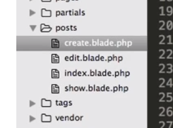

1. we will create our crud as usual. But the VIEW will be simply a table displaying all of our linked pages and navbar pages. So a really for us an, EDIT, SHOW INDEX for ADMIN Looking like this beside here.

2. EDIT PAGE WILL BE SOMETHING LIKE THIS with the WYSIWIG.

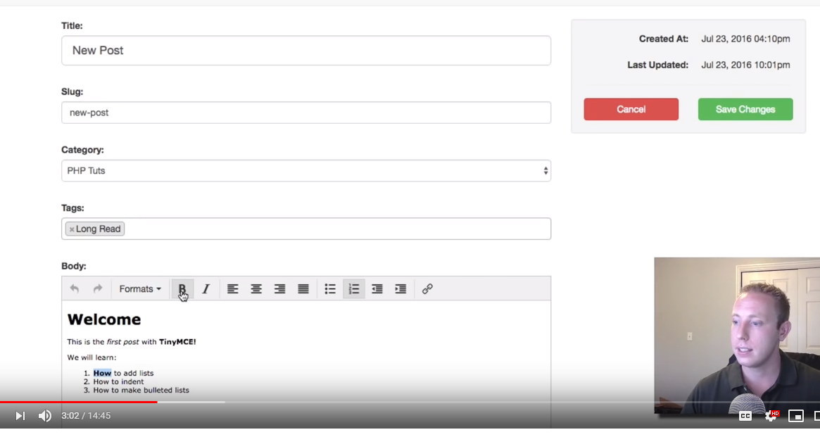

3. the View page will look something like a simple list, with the various pages and an edit button on the right side. Then they open up to the above!

4. Then what will be built around the “textarea” is the WYSIWIG and I think TINYMCE is best.

5. We render then from the Database, to the main pages as they grab the ID from each page.